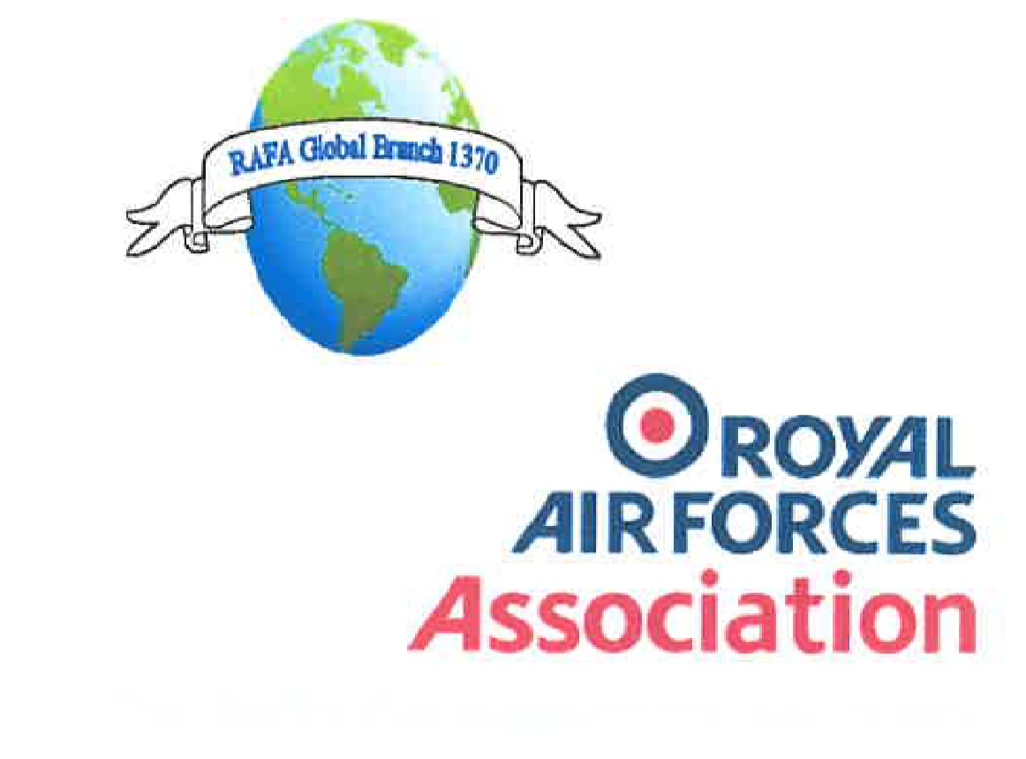
The charity that supports the RAF family

RAFA Global Branch 1370 Minutes of committee meeting held on the 09th January 2022 at 1900 hours

Attendees: Mr Steve Mullis - Chairman
Mr Andrew Thomson - Secretary \
Ms Nicky Loveday - Welfare officer
Mr Gerwyn Thomas - Membership Secretary
Mr Graham Croft - Wings member
(Sgt) Dai Lawrence - RAF Valley Liaison
(Fg Off) Aidan Rae - RAFALO RAF Valley

Item 1: Apologies:
- Mr Richard Wiltshire – Treasurer, Mrs Mazza Holland - Social member

Item 2: Minutes of the last meeting (07th November 2021).
- The minutes of the last meeting were read and approved as a true record

Item 3: Matters arising from the last minutes.
- Nil
Item 4: Chairman’s report
- The Chairman firstly introduced the RAF Valley Liaison officers for our up-and-coming AGM, Sgt Dai Lawrence and Fg Off Aidan Rae both welcoming and thanking them for their assistance so far in the organisation of the same. He went on to give the following information:

- Details of AGM attendance: Currently 27 members + 11 guests attending AGM with 9 maybes of which 2 are possible.

- Comments to Sgt Lawrence:

- What, if any identification, or any other personal details are required by those attending the AGM to get on base – Only full names and where they are coming from as cars will be parked in the Secure Eastern Airways car park off base. Personnel will be issued with blue badges and escorted at all times. MT buses will be provided with a maximum of 25 persons per bus
- A Further point is that MT will be reserved for the evening also

- Update about the current Premier Inn Covid precautions:
Masks must be worn at all times when outside Hotel bedrooms.
Restaurants are open and serving meals
Where possible 2m social Distance should be practiced.
Rooms are not serviced daily but only every 3 days.
All appropriate "National Restrictions" are in force at Premier Inns.
This information is from an employee of Premier Inn, and will keep us informed if any Premier Inn precautions change.

d) Itineraries

Friday 4th March 2022

15.00hrs +

Arrival time at accommodation

20.00hrs

Social Evening & meal at Premier Inn, Parc Cybi, North Wales, LL65 2YQ

We are being joined by the President & Chairman of the RAFA Anglesey along with Fg Off Aidan Rae, the RAF Valley RAFALO & Sergeant David ‘Dai’ Lawrence, who has been our point of contact.

Saturday 5th March

1. 09.00hrs – 15.00hrs approx.

Transfer by private cars to RAF Valley

Members will be split into 2 groups, for Covid safety, for Visits to Sqn’s on RAF Valley, a charity aircraft pull and for Lunch in the Officers Mess. A visit to the Station History Room is also still a possibility. Details of the charity aircraft pull are still being finalised.

1500 – 1800 – RAFA Members retire to Holyhead Premier Inn for comfort break

1800-2330 WOSM

a. 1800 – 1900 – RAFA Representatives arrive including Anglesey RAFA Branch members – President and Chairman CC’d
b. 1900 – 1945 – Global AGM to be held both physically and via IT/Wifi in the Ante Room with Video Link to the Global Members that are unable to attend
c. 1945 – 2000 – Admin Break / Bar top up d. 2000 – 2100 – Historical Air Power talk – The Dambusters
e. 2100 – 2200 – Non formal meal – 2 Hot Meals plus a vegetarian option
f. 2200 – 2330 – Use of WOSM Bar
g. 2330 – Depart back to hotels

Sunday 6th March

08.00hrs – 12.00hrs

Breakfast & check out of accommodation

Finally, the Chairman asked that ALL be aware that the final date for application to attend will be SUNDAY 27th Feb 2022. ANY request to join us after that date will NOT be considered due to the security restrictions placed on us by the base. Do please note that the above information is subject to change

All the above information has since been posted on Facebook by the Chairman

Item 5: Treasurers report
i) The Treasurer reported the following figures
Community: £3151.75 (total)
Welfare: £436.96
Wings: £0

Item 6: Welfare officers report

- The Welfare officer reported that there has been nothing of significance to report, however ongoing advice to some members has been given
Item 7: Secretary’s report
i) The Secretary reminded the committee that forms will be sent out very soon and would appreciate prompt returns of the same.
Item 8: Wings report
- There was nil input to the Wings account
Item 9: Social report
i) Nothing to report
Item 10: Any other reports
i) The Membership secretary supplied the following figures for the branch:
Total: 590 members
Comprising: 314 ordinary
166 lifetime
44 associate
66 Give As You Earn
Item 11: Other Notified items
i) Nil
Item 11.1: Items raised by members
i) Nil
Item 12: Any Other Business
i) Sgt Lawrence mentioned that he has arranged for Station photographers to attend Friday and Saturday for official photographs
As there was no other business for discussion the meeting was closed at 1930 with the date of the next meeting 20th February 2022 at 1900 hours

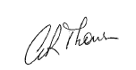

Andrew Thomson
Honorary Secretary
RAFA Global Branch 1370

