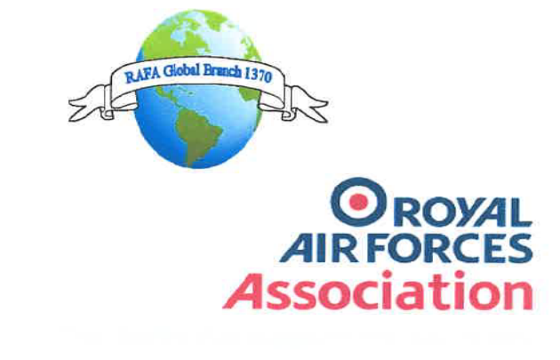
The charity that supports the RAF family
RAFA Global Branch 1370 Minutes of committee meeting held on the 16th May 2021 at 1900 hours
Attendees: Mr Steve Mullis
Mr Andrew Thomson
Mr Graham Croft
Ms Nicky Loveday
Mr Gerwyn Thomas
Mr Richard Wiltshire

Item 1: Apologies:
- Mr Damian Harris, Mr David Routledge, Mrs Mazza Holland

Item 2: Minutes of the last meeting (29th Nov 2020).
- There was no meeting held in April out of respect to the passing of Prince Philip. The minutes of the last meeting (AGM March 2021) were read and approved as a true record

Item 3: Matters arising from the last minutes.
Nil

Item 4: Chairman’s report
i) The Chairman mentioned that all was proceeding ok and hopefully all would be opening up once more after the June lifting of the current Covid restrictions (All should now be aware this is no longer the case and should know more by either the 5th or 19th July). Although, by the time of the next AGM we would like to be able to hold this at RAF Valley as per the plans before the current Covid restrictions, and therefore look forward to be able to start arranging this.
ii) Members will shortly be send a DPA form by the Secretary to be signed and returned as soon as possible
iii) The Chairman mentioned that since being asked to take on new members from the now closed Camberly and Woking branches, this has so far amounted to 167 members. Some of these are being sent across by HQ without contact details and therefore, as far as the branch is concerned without their permission. Some are also from outside (overseas South Africa) the aforementioned closed branches. Fairly obviously this has led to an increased workload for the branch Chairman and Membership Secretary. It was generally agreed by all that before things become 'uncontrollable' movement of members must be clarified along with contact details. It should be noted at this point that the branch is obviously more than happy to accept new members particularly to give them a proper branch to be a member of rather than being assigned to the HQ roll and forgotten. (The Chairman therefore agreed to speak to relevant persons at HQ to gain agreement that this will be organised properly and notifications sent - this has in fact now been reassured by email)
Item 5: Treasurers report
The following figures were supplied by the Treasurer.
Ordinary account: £2986.13
Welfare account: £ 461.64
These figures include a payment of £20.00 given to RAFA members for a stand payable to Thatcham town council

Item 6: Welfare officers report
i) Relatively quiet, the food bank project has now been wound up with RAFA to order a food parcel from Morrisons.
ii) The Welfare officer went on to propose that we consider a membership gift to a 100 year old veteran so he was able to remain part of the RAF family. The committee readily agreed to this and was seconded by the membership secretary

Item 7: Secretary’s report
Nil, very quiet. However would like everyone to ensure their gmail account emails are working if possible

Item 8: Wings report
Nil, very quiet. Would like to suggest some activities as per last year.

i) Looking to arrange a wine tasting at his local village hall and have a RAFA stand with some goods along with a donation box. No licence would be required for an indoor collection. (Wings member will report on the possibility of this as there is so far no reason why this could not go ahead)

ii) The idea was mooted to the idea of a form of lottery for the branch. Probably taking the shape of the 'bonus ball' type of which 60% of collected monies would go to the winner and the rest into the RAFA fund. (This will be researched by the Chairman and Treasurer and the feasibility reported on at a later date)

Item 9: Social report
Nil, very quiet. However the Chairman has suggested

i) A visit to the Arboretum at some point in the near future TBA.

ii) Also mentioning the annual conference which was to be held in October. Please note the annual conference will now be a virtual conference once again due to the ongoing Covid restrictions (as per recent email received)

Item 10: Any other reports
- The Membership representative supplied the following figures for the branch:
Total: 575 members
Comprising: 312 ordinary
153 lifetime
44 associate
66 Give as you earn
Item 11: Other Notified items
Nil
Item 11.1: Items raised by members
Nil
Item 12: Any Other Business
i) The Chairman mentioned his wife (Julie) had now completed her virtual sponsored walk by completing the equivalent distance from Bristol to London, mentioning that the donations 'giving' page does not close. Congratulations were offered to Julie by the committee, certainly a very worthwhile achievement for her charity, Guys and St Thomas's Hospital

As there was no other business for discussion the meeting was closed at 2000 date of next meeting TBD

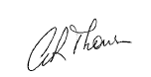

Andrew Thomson
Honorary Secretary
RAFA Global Branch 1370

